PES University, Bengaluru 

(Established under Karnataka Act 16 of 2013)

Department of Computer Science & Engineering Session: Jan - May 2022

UE19CS353 – Object Oriented Analysis and Design with Java Theory ISA (Mini Project)

Report on

Shop Management System

By:

Shreyas Ganesh – PES2UG19CS387

Saurabh Yadav – PES2UG19CS371

Satwik Bansal – PES2UG19CS470

Sapna Singh – PES2UG19CS366

6th Semester Section F

**TABLE OF CONTENTS**

| **Chapter No.** | **Title** | **Page No.** |
| --- | --- | --- |
| **1.** | **PROJECT DESCRIPTION** | **01** |
| **2.** | **ANALYSIS AND DESIGN MODELS** | **02** |
| **3.**  **4.** | **TOOLS AND FRAMEWORKS USED**  **DESIGN PRINCIPLES AND DESIGN PATTERNS USED** | **03**  **04** |
| **5** | **APPLICATION SCREENSHOTS** | **05** |
| **6** | **TEAM MEMBER CONTRIBUTIONS** | **08** |
| **7.** | **CONCLUSION** | **09** |
| **8.** | **REFERENCES** | **09** |

**LIST OF FIGURES**

| **Figure No.** | **Title** | **Page No.** |
| --- | --- | --- |

2.1 Master Use Case Diagram 5

2.2 Master Class Diagram 6

2.3 Activity Diagram 7

2.4.1 Customer State Diagram 7

2.4.2 Shopkeeper State Diagram 8

5.1 View Product Interface 10

5.2 Login Interface 10

5.3 Purchase History Interface 11

5.4 Edit Profile Interface 11

1. **Project Description**

Creating a shop management system to help with the efficient functioning of the shop it's deployed in. It provides necessary features to help various entities. There are 3 profiles in the application: customer, shop inventory, and shopkeeper.

Customers and shopkeepers are for smoothing transactions.

Shop inventory profile would help keep track of stocks and customer demands. The inventory tracking can be used to maximize profits by identifying the most and least sold products.

The customer profile is for each individual customer to add things to the cart. Storage of cart details. Gives unique identification for each customer, and quick payment options.

Shopkeeper profile contains shop id to identify stores uniquely, transaction IDs. Details about the items sold on a particular day on his shift and details about the items sold at his store. Keeping track of transaction logs by date.

LINK TO GITHUB: <https://github.com/shreyasganesh01/ShopManagement.git>

**2. Analysis and Design Models**

**Use Case Diagrams:**

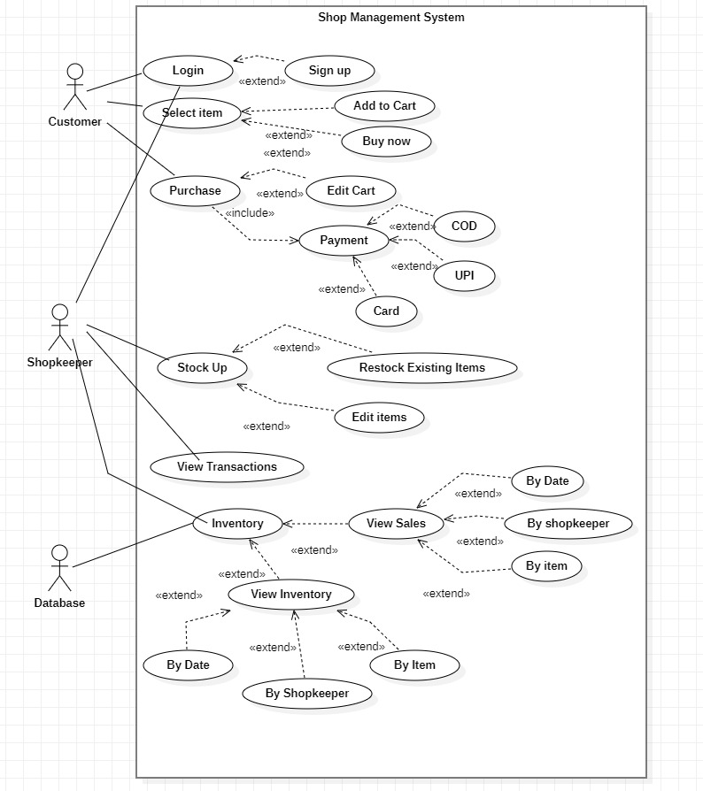

Fig 2.1

**Class Diagrams:**

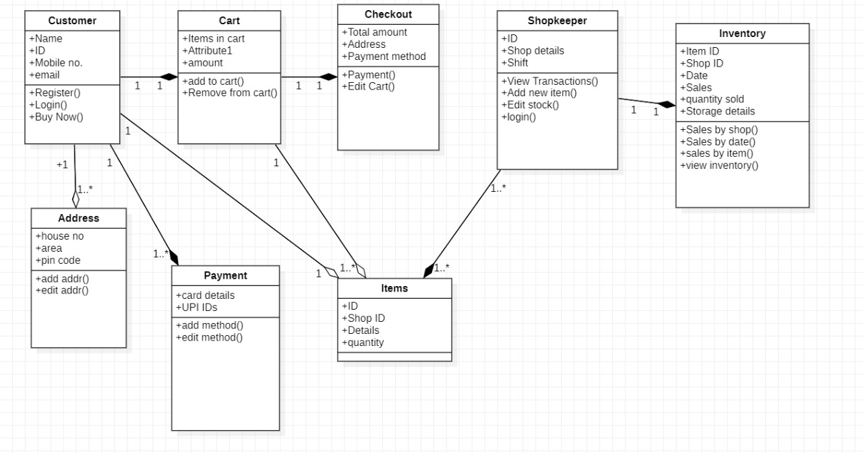

fig2.2

**Activity Diagram:**

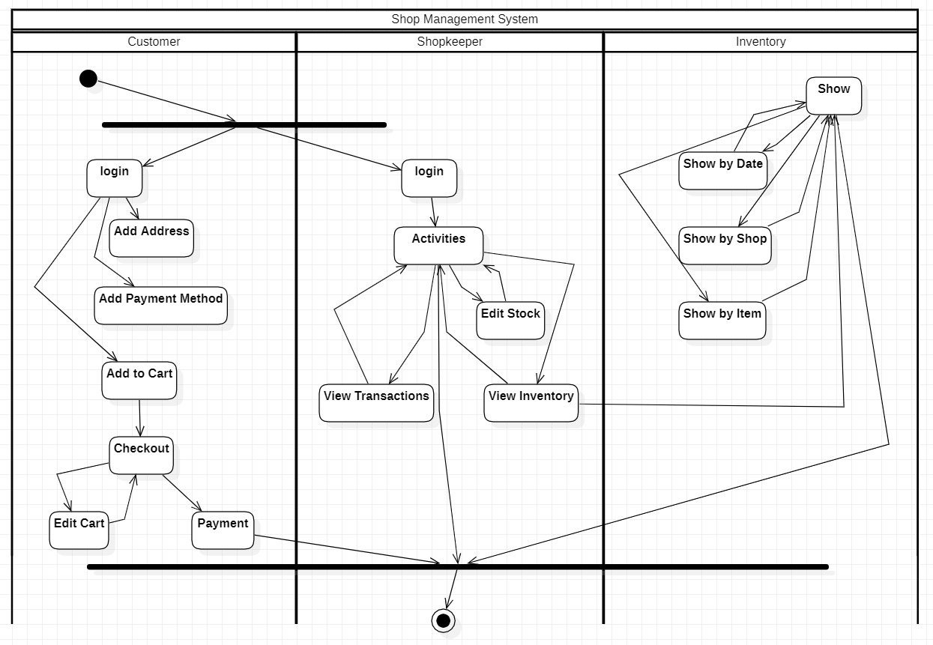

Fig 2.3

**State Diagrams:**

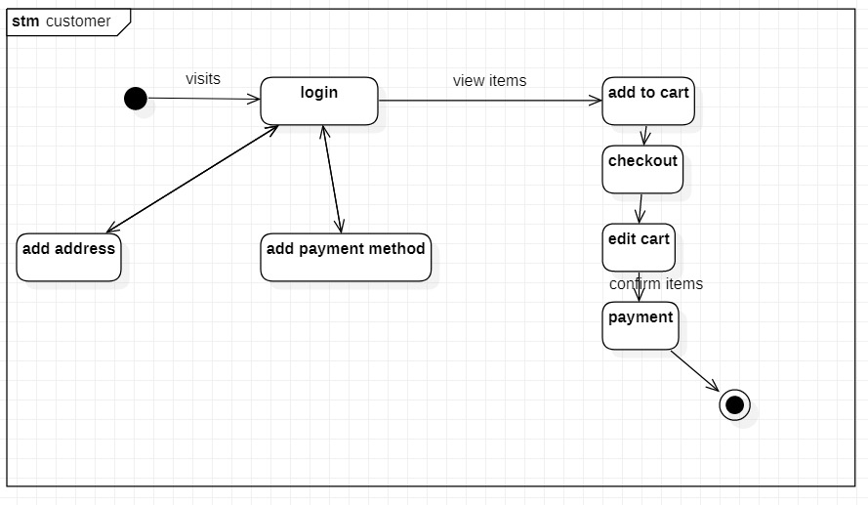

Fig 2.4.1

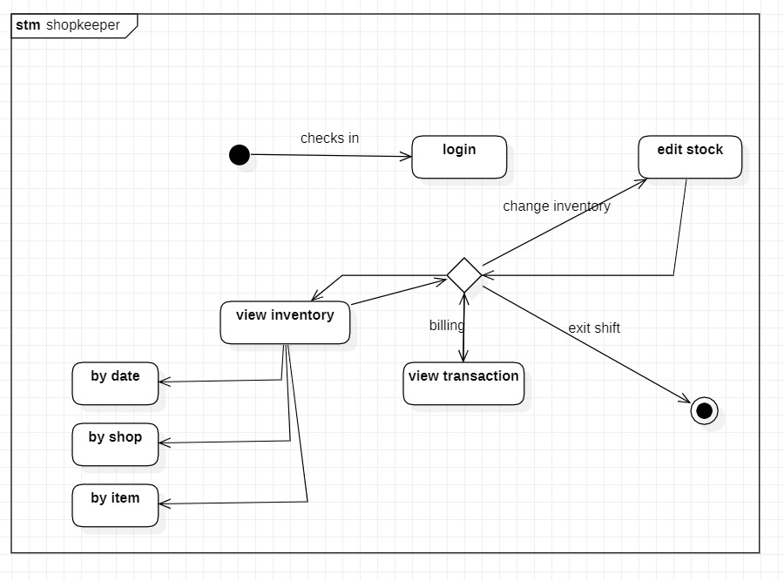

Fig 2.4.2

**3. Tools and Frameworks used**

**Java swing:** Swing in java is part of the Java foundation class which is lightweight and platform-independent. It is used for creating window-based applications. It includes components like buttons, scroll bar, text fields, etc. Putting together all these components makes a graphical user interface.

**Java AWT:** Java AWT (Abstract Window Toolkit) is an API to develop Graphical User Interface (GUI) or windows-based applicationsin Java.

Java AWT components are platform-dependent i.e. components are displayed according to the view of the operating system. AWT is heavyweight i.e. its components are using the resources of the underlying operating system (OS).

**Mysql:** MySQL is a relational database management system based on SQL – Structured Query Language. The application is used for a wide range of purposes, including data warehousing, e-commerce, and logging applications. The most common use for MySQL however, is for the purpose of a web database.

**4. Design Principles and Design Patterns Applied**

Design pattern :- The project implements a Behavioural design pattern: adapter.

An Adapter Pattern says that it just "converts the interface of a class into another interface that a client wants".

The project implements this using various activity interfaces that implement a common "ActionListener" interface which is then changed according to the activity i.e Login, Signup,Customer, ProfileProduct, etc

Design Principle:- MVC (Model-View-Controller) is a pattern in software design commonly used to implement user interfaces, data, and controlling logic. It emphasizes a separation between the software's business logic and display. This "separation of concerns" provides for a better division of labor and improved maintenance. Some other design patterns are based on MVC, such as MVVM (Model-View-Viewmodel), MVP (Model-View-Presenter), and MVW (Model-View-Whatever).

The three parts of the MVC software-design pattern can be described as follows:

Model: Manages data and business logic.

View: Handles layout and display.

Controller: Routes commands to the model and view parts.

**5. Application Screenshots (3-4 important pages)**

**Product**

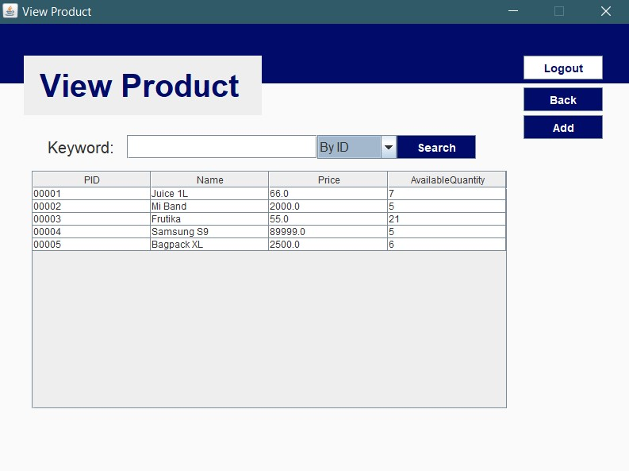

Fig 5.1

**Login_page**

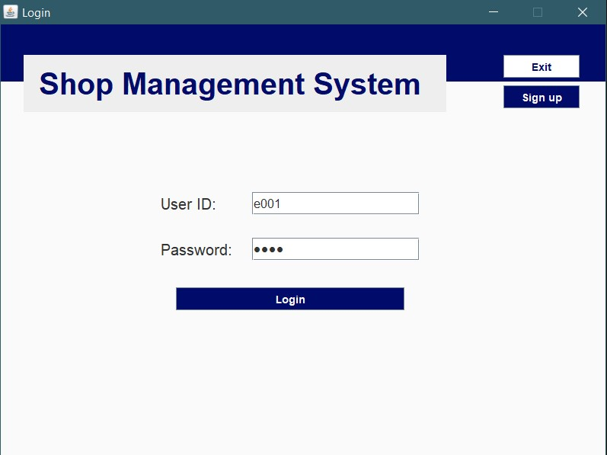

Fig 5.2

**History**

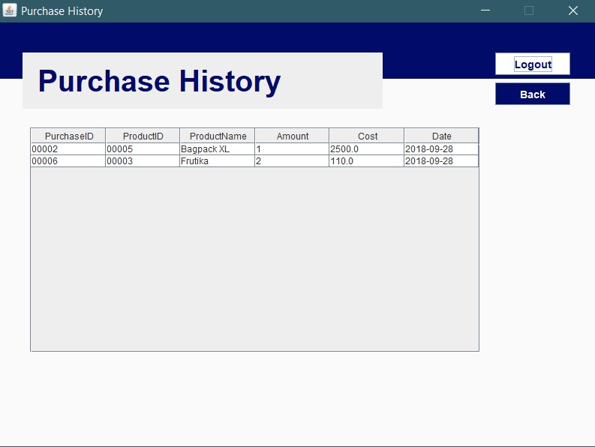

Fig 5.3

**Edit_profile**

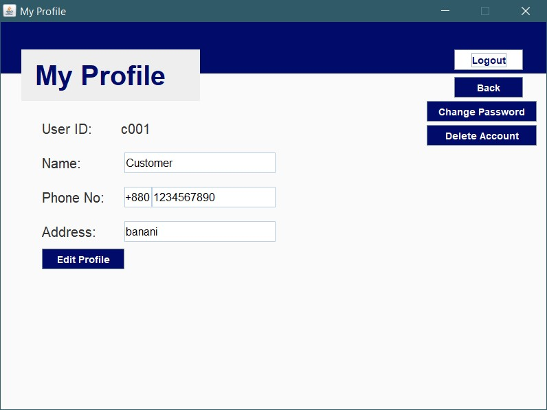

Fig 5.4

**6. Team member contributions**

| **Name** | **SRN** | **Contribution** |
| --- | --- | --- |
| Shreyas Ganesh | PES2UG19CS387 | 40% |
| Saurabh Yadav | PES2UG19CS371 | 40% |
| Satwik Bansal | PES2UG19CS470 | 10% |
| Sapna Singh | PES2UG19CS366 | 10% |

**7. Conclusion:** The shop management project was made using java swing, MySQL, and architecture design pattern. It should efficiently be able to smoothen the functioning of the shop, reducing human effort and providing better management.

8.**References:**

<https://www.scitepress.org/Papers/2016/59860/59860.pdf>

<https://docs.oracle.com/javase/7/docs/api/java/awt/package-summary.html>

<https://docs.oracle.com/javase/8/docs/api/java/sql/package-summary.html>